SYNOPSIS
- TITLE
Edument
- INTRODUCTION
A web portal project that acts as an interface between students and the teachers. The system is designed for worldwide use. Students can register and
Modules:
- Student Login
- Admin login
- Dashboard
- Lecture plan
- Test
- Online class
- Video lecture
- Notes
- Calendar
- Mail
- Library
  - PROJECT BENEFITS
- Any student can be capable of reviewing his profile.
- Students are not bounded to their college faculties.
- It’s a platform where students can open up to ask queries.
- Stay better informed any notices.
- Student gets prepared for online exams via online test module.
- Students can clear doubts from faculties.
- Student can have access to the class notes.
- It bridges the gap among students.
- Gaining extra knowledge from the internet is just one click away with e-library.
- Student can avail required study material anywhere around the world.

  - PROJECT SCOPE
The scopes of this project are:
- Any institute can use this system as it is not client centric.
- All academics related work for the student can be done using this system.
- Deliver Electronic Workplace.
- Application Support & Maintenance after deployment to production.
- Provides network between the student and experts.
- Students can easily analyze his/her strong and weak areas with the help of charts.
- The missed classes will not be treated missed as it contains notes sharing facility.
- Student can go through the video lectures for strong and better way of understanding.
- It consists of an e-library which will be acting as a helping hand in the course arena.
- Storing call records.
- PROBLEM STATEMENT
Many unpredictable factors may affect a student life. One of the major issue is where he/she was lacking in the performance. This problem is usually faced in any student life. One has to keep waiting for long which may affect his or her time. It is very difficult to collect the notes of missed classes. Students are not aware about their own capabilities. Due to their busy schedule they don’t have enough time for self assessment. Painfully loud), though the microphone volume is usually adjustable too but deaf person can’t be benefited.
4. OBJECTIVES
- Our objective is to create a dynamic student portal that acts as a gateway for just-enough, just-in-time information for all students.
- The portal will direct students to on-campus resources and tools and provide timely and customized information and communications to support student transition through the student lifecycles.
- A portal will address the student need for relevant and effective information sharing and allow students to customize the information available to them.
5. INTENDED USER
The intended users are the Students and Teachers.
6. EXISTING SYSTEM
The application “Student Ingress Ledger” is basically for the students for their overall analysis . whenever they want to know about the current status. In this web based application a student is a client who can access the server to extract information for the same.
In the ”Student Ingress Ledger” web based application the end user has to feed data about the student report in order to generate an analysis chart for self assessment. This data is then sent to a server and then the server sends a request to the client server. After checking the detailed database from the server a response is reverted back to the end user.
Many IITs and NITs are using the student management system which consist the information of many different aspects like fees, administration, placement, clubs etc.
This project is embedded only for academics.

6.1 PROCESS FLOW
Server

Admin
Students

Figure 1:Process Flow of Existing System – “Student Ingress Ledger”

6.2 LIMITATIONS
Some limitations of the existing system are:
- Person should be an Authorized person.
- Application will appear in form of English.
- Existing system is not fully automated.
- Network should be free of any disruptions.
- Time consuming process i.e. unavailability of information on time.
7. PROPOSED SYSTEM
The proposed system “Student Ingress Ledger” is an web based application that is a MIS: Management Information System. Student Ingress Ledger is different from other software as its main focus is to strengthen the communication link between student and teacher. Student Ingress Ledger is the software to provide the service of analytics in the form of graphs and charts. The Student Ingress Ledger allows students to view important notices and events. This application also has the feature of in-house mailing system and an academics calendar.
7.1 SYSTEM FEATURES
- Student can view the updates regularly.
- Student can have the overall analysis report.
- Use of calendar as a reminder.
- E-Library for different source of study material.
7.2 PROCESS FLOW
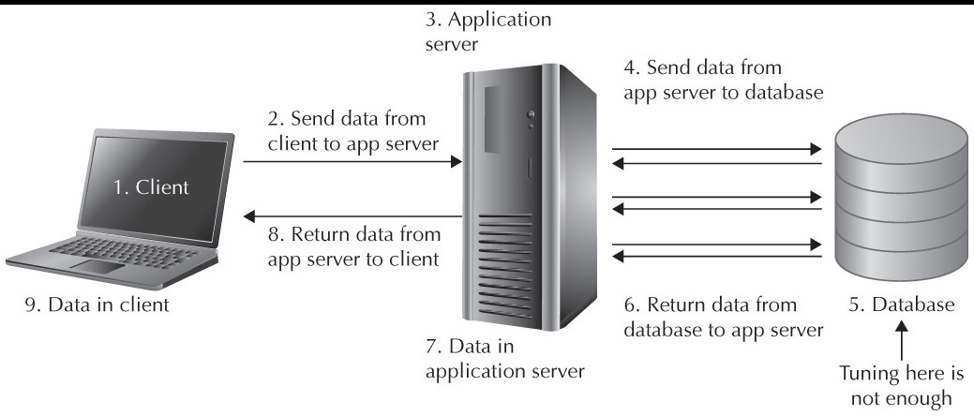
Figure 2: Process Flow Of Proposed System
7.3 HARDWARE REQUIREMENT
- Any system that consist of an Internet connection.

  - SOFTWARE REQUIREMENT
- Sublime Text 3
8. EXPECTED OUTCOMES
- Improvement in Student-Teacher relationships.
- Students will not suffer from academics losses due to missed classes.
- Self assessments and improvement in academics.
- Proper scheduling of events.
9. CONCLUSION
This is to conclude that the project that we undertook was worked upon with a sincere effort. Most of the requirements have been fulfilled up to the mark and the requirements which have been remaining, can be completed with a short extension. This project would definitely satisfy all the requirements of the college and would be beneficial for the students and the college staff.
9.1 LIMITATIONS
- Internet is required.
- For PDFs storage capacity is a concern.
- There will be only one admin.
- The upload option is available to admin and teachers only.
- GUI is only in English.
- The web portal will be constrained by the capacity of the database. Since the database is shared it may be forced to queue incoming requests and therefore increase the time it takes to fetch data.
  - FUTURE ENHANCEMENTS
- Student timeline for more interaction.
- Uploading from student end also.
- Sharing of notes.
- Payment modes.
- Guest lecture classroom for extra knowledge.

10. REFERENCES
- Danny Goodman, “JavaScript Bible” , June 01 , 2001.
- Roger S. Pressman, “Software Engineering – A Practitioner’s Approach” , November 01 , 2012.
- Ian Somerville, “Learning PHP, MySQL & JavaScript: With JQuery” , August 16 , 2012.
- “Eloquent JavaScript: A Modern Introduction to Programming” by Marijn Haverbeke
- “Programming JavaScript Applications: Robust Web Architecture with Node, HTML5, and Moderns JS Libraries” by Eric Elliott
- www.google.com
  - Google search engine official website.
- http://sourceforge.net/
  - Largest repository of open source code and applications available on the internet.
- http://www.gnu.org
  - Web site of the Free Software Foundation (FSF) which supports the open source community.
- http://www.thefreecountry.com
  - Large collection of good programming resources.
- http://www.1001tutorials.com/
  - Large collection of good tutorials for reference.
- http://www.codeguru.com/
  - Good articles on programming.

Signature of the Candidate Signature of the supervisor

